Project Report

Autonomous Rover



Submitted by:
Thota. Venkata Vivek Reg. Id: 15241A04H5
Section: ECE-C

Index
- Introduction
- Block Diagram
- Circuit Diagram
- Requirement Specifications
- Hardware
- Software
- Bill of Materials
- Board Layout
- Program
- Functional Operation
- Applications
- Conclusion

Introduction
The autonomous rover project is centered on the idea in order to reach to the physically in-accessible locations by humans to achieve the goals such as to surveille the area and analyze the environment conditions in the expedition. Besides, surveillance it carries the moto to research on the detected object and its environment particulars. The research mode in the rover is made to take the temperature, humidity and lighting conditions, by using the robotic arm in order to reach closely towards the object and report to the user for in-depth analysis.
Block Diagram
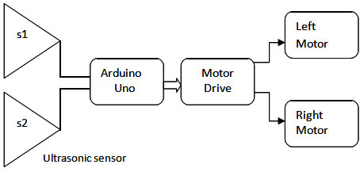
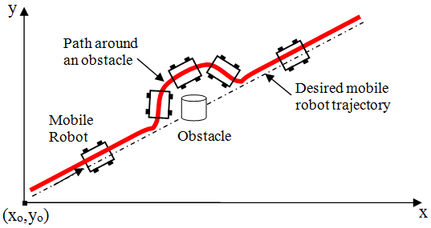

Circuit Diagram of Autonomous Rover:
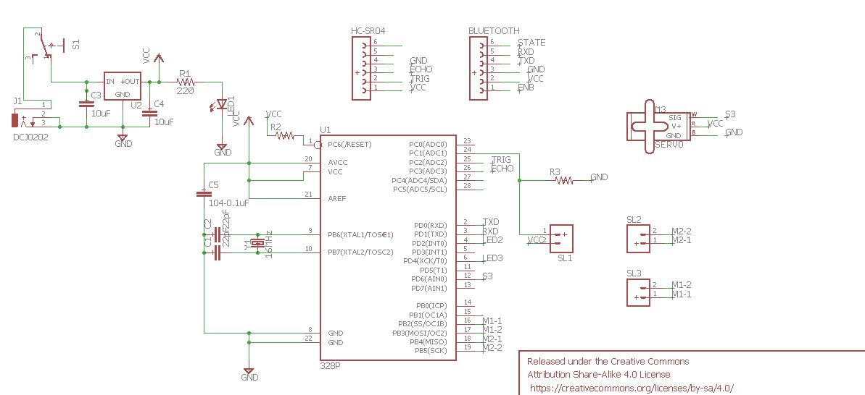

Requirement Specifications
- Hardware
- ATmega 328 Microcontroller
- Dual- Shaft DC Motor
- Micro Servo – Motor(SG90)
- Ultrasonic Sensor
- LDR sensor
- L293D Motor Driver
- Male Berg and Female Bergs
- Crystal – 16Mhz
- Capacitors and Resistors
- DC Jack and Switch
- LED’s
- Bluetooth(HC-05)/Wi-Fi(ESP8266)

- Software
  - Eagle CAD Software (Custom PCB Design)
  - Arduino IDE
  - MIT App Inventor

Bill of Materials

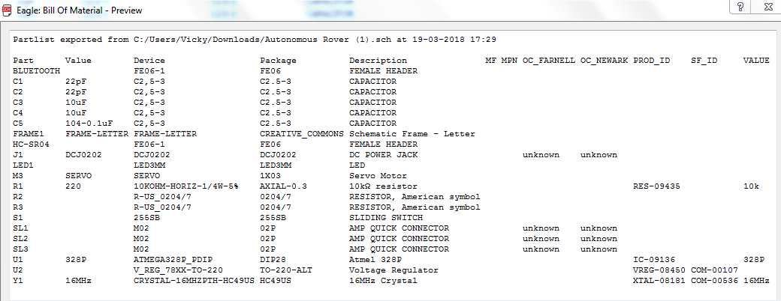
ATmega328P Microcontroller:
The high-performance Microchip 8-bit AVR RISC-based microcontroller combines 32KB ISP flash memory with read-while-write capabilities, 1KB EEPROM, 2KB SRAM, 23 general purpose I/O lines, 32 general purpose working registers, three flexible timer/counters with compare modes, internal and external interrupts, serial programmable USART, a byte-oriented 2-wire serial interface, SPI serial port, 6-channel 10-bit A/D converter (8-channels in TQFP and QFN/MLF packages), programmable watchdog timer with internal oscillator, and five software selectable power saving modes. The device operates between 1.8-5.5 volts.

The table below gives a description for each of the pins, along with their function.
Specifications:
• IC type: AVR microcontroller
• Core size: 8-bit
• Speed: up to 20MHz
• Number of I/O: 23
• Program memory size: 32Kb (16K x 16)
• Program memory type: Flash
• EEPROM size: 1K x 8
• RAM size: 2K x 8
• Package: DIP-28 (0.1" x 0.3" pin spacing)
• Supply voltage: 1.8 V - 5.5 V

Ultrasonic Ranging Module HC - SR04:
Ultrasonic sensors are ideally suited to accurate, automatic distance measurement in normal and difficult environments. Ultrasonic sensors are particularly suitable for environments where optical sensors are unusable such as smoke, dust and similar. Ultrasonic sensors are very accurate, stable and can be used over large ranges.
Ultrasonic sensors can measure the following parameters without contacting the medium to be measured
•Distance
•Level
•Diameter
•Presence
•Position
Ultrasonic sensors make accurate measurements in many difficult environments and unusual materials. Measurements are unaffected by:
•Material
•Surface
•Light
•Dust
•Mist and Vapour

Product features:
Ultrasonic ranging module HC - SR04 provides 2cm - 400cm non-contact measurement function, the ranging accuracy can reach to 3mm. The modules includes ultrasonic transmitters, receiver and control circuit. The basic principle of work:
(1) Using IO trigger for at least 10us high level signal.
(2) The Module automatically sends eight 40 kHz and detect whether there is a pulse signal back.
(3) IF the signal back, through high level , time of high output IO duration is the time from sending ultrasonic to returning. Test distance = (high level time velocity of sound (340ms)) / 2,
Timing diagram:
The Timing diagram is shown below. You only need to supply a short 10uS pulse to the trigger input to start the ranging, and then the module will send out an 8 cycle burst of ultrasound at 40 kHz and raise its echo. The Echo is a distance object that is pulse width and the range in proportion .You can calculate the range through the time interval between sending trigger signal and receiving echo signal. Formula: us / 58 = centimetres or us / 148 =inch; or: the range = high level time * velocity (340M/S) / 2; we suggest to use over 60ms measurement cycle, in order to prevent trigger signal to the echo signal.

IC 7805 (Voltage Regulator IC):
7805 is a voltage regulator integrated circuit. It is a member of 78xx series of fixed linear voltage regulator ICs. The voltage source in a circuit may have fluctuations and would not give the fixed voltage output. The voltage regulator IC maintains the output voltage at a constant value. The xx in 78xx indicates the fixed output voltage it is designed to provide. 7805 provides +5V regulated power supply. Capacitors of suitable values can be connected at input and output pins depending upon the respective voltage levels.

Crystal:
An electronic circuit or electronic device that is used to generate periodically oscillating electronic signal is called as an electronic oscillator. The electronic signal produced by an oscillator is typically a sine wave or square wave. An electronic oscillator converts the direct current signal into an alternating current signal. The radio and television transmitters are broad casted using the signals generated by oscillators. The electronic beep sounds and video game sounds are generated by the oscillator signals. These oscillators generate signals using the principle of oscillation.

MOTOR DRIVER (L293D)
L293D is a typical Motor driver or Motor Driver IC which allows DC motor to drive on either direction. L293D is a 16 pin IC which can control a set of two DC motors simultaneously in any direction. It means that you can control two DC motor with a single L293D IC. Dual H-bridge Motor Driver integrated circuit(IC).
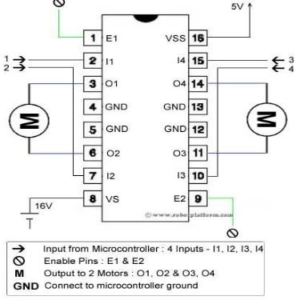
MOTORS
A DC motor in simple words is a device. An Electric DC motor is a machine which converts electric energy into mechanical energy.
This DC or direct current motor works on the principal, when a current carrying conductor is placed in a magnetic field, it experiences a torque and has a tendency to move. This is known as motoring action. If the direction of current in the wire is reversed, the direction of rotation also reverses.
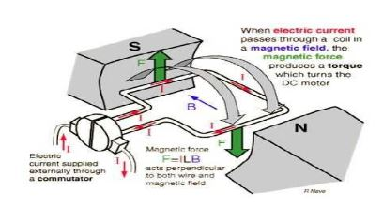

SG90 9g Micro Servo
Tiny and lightweight with high output power. Servo can rotate approximately 180 degrees (90 in each direction), and works just like the standard kinds but smaller. You can use any servo code, hardware or library to control these servos. Good for beginners who want to make stuff move without building a motor controller with feedback & gear box, especially since it will fit in small places. It comes with a 3 horns (arms) and hardware.
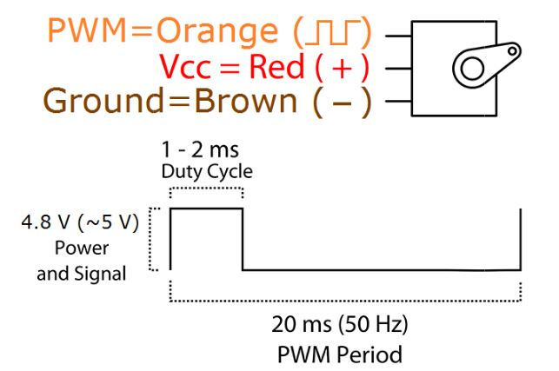

HC-05 Bluetooth Module
- HC-05 is a Bluetooth module which is designed for wireless communication. This module can be used in a master or slave configuration.
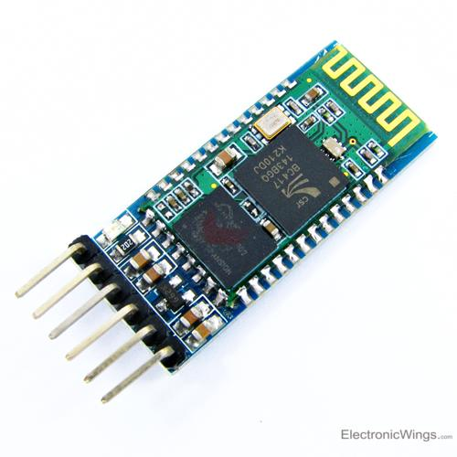
HC-05 Bluetooth Module

Pin Description
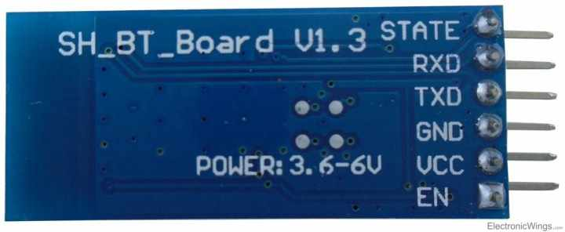
Bluetooth serial modules allow all serial enabled devices to communicate with each other using Bluetooth.
It has 6 pins,
1. Key/EN: It is used to bring Bluetooth module in AT commands mode. If Key/EN pin is set to high, then this module will work in command mode. Otherwise by default it is in data mode. The default baud rate of HC-05 in command mode is 38400bps and 9600 in data mode.
2. VCC: Connect 5 V or 3.3 V to this Pin.
3. GND: Ground Pin of module.
4. TXD: Transmit Serial data (wirelessly received data by Bluetooth module transmitted out serially on TXD pin)
5. RXD: Receive data serially (received data will be transmitted wirelessly by Bluetooth module).
6. State: It tells whether module is connected or not.
HC-05 module Information
- HC-05 has red LED which indicates connection status, whether the Bluetooth is connected or not. Before connecting to HC-05 module this red LED blinks continuously in a periodic manner. When it gets connected to any other Bluetooth device, its blinking slows down to two seconds.
- This module works on 3.3 V. We can connect 5V supply voltage as well since the module has on board 5 to 3.3 V regulator.
- As HC-05 Bluetooth module has 3.3 V level for RX/TX and microcontroller can detect 3.3 V level, so, no need to shift transmit level of HC-05 module. But we need to shift the transmit voltage level from microcontroller to RX of HC-05 module.

Board Layout
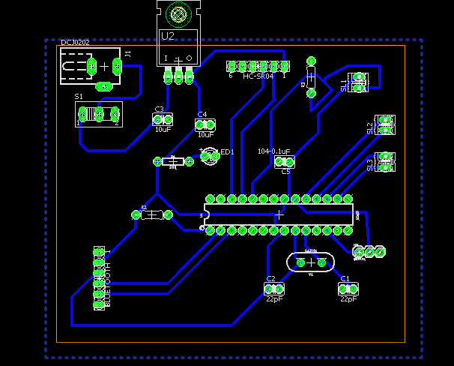
The Libraries used are Sparkfun and Adafruit.
https://github.com/sparkfun/SparkFun-Eagle-Libraries
Program:
#include <Servo.h>
//#include <SoftwareSerial.h>
#include "Ultrasonic.h"
//#include "DHT.h"
//#define dht_pin=A0

//dht DHT;
//Constants - Connections
const int motorA1= 10;
const int motorA2= 11;
//const int enableA = 3;
const int motorB1= 12;
const int motorB2= 13;
//SoftwareSerial mySerial(0,1);//RX,TX
//const int enableB = 7;

Ultrasonic ultrasonic(A2 ,A3); //Create Ultrsonic object ultrasonic(trig pin,echo pin)
Servo myservo; //Create Servo object to control a servo

//Variables
int distance; //Variable to store distance from an object
int checkRight;
int checkLeft;
int pos=100; //Variable to store the servo position. By default 90 degrees - sensor will 'look' forward
//int speedPWM = 255; //Change speed (PWM max 255)

void setup()
{
Serial.begin(9600);
myservo.attach(6); //Servo pin connected to pin 7
myservo.write(pos); // tell servo to go to position in variable 'pos'
pinMode(3,OUTPUT);
pinMode(motorA1,OUTPUT);
pinMode(motorA2,OUTPUT);
pinMode(motorB1,OUTPUT);
pinMode(motorB2,OUTPUT);
//pinMode(enableA, OUTPUT);
//pinMode(enableB, OUTPUT);
delay(5000); //Wait 5 seconds...
distance = ultrasonic.Ranging(CM);
}

void loop(){
//analogWrite(enableA, speedPWM);
//analogWrite(enableB, speedPWM);
//Read distance...
//while(mySerial.available())
//{
//char state = mySerial.read();
//if(state=='1')
//{

distance = ultrasonic.Ranging(CM); //Tip: Use 'CM' for centimeters or 'INC' for inches
delay(20);
//Check for objects...
if (ultrasonic.Ranging(CM) > 15){
forward();
Serial.print("Voyage started");
Serial.print("Object is at:");
Serial.println(distance);
}
else if (ultrasonic.Ranging(CM) <=15){
stop();
Serial.print("Object is at: ");
Serial.println(distance);//Object detected! Stop the robot and check left and right for the better way out!
delay(500);
Serial.println("Sensing the area...");
for(pos = 30; pos < 170; pos += 1){ //goes from 0 degrees to 180 degrees
myservo.write(pos);
//digitalWrite(3,HIGH);//tell servo to go to position in variable 'pos'
delay(10); //waits 10ms for the servo to reach the position
}

checkLeft = ultrasonic.Ranging(CM); //Take distance from the left side

for(pos = 170; pos>=30; pos-=1){ //goes from 180 degrees to 0 degrees
myservo.write(pos);
//digitalWrite(3,HIGH);//tell servo to go to position in variable 'pos'
delay(10); //waits 10ms for the servo to reach the position
}

checkRight= ultrasonic.Ranging(CM);

myservo.write(100); // Sensor "look" forward again

//Finally, take the right decision, turn left or right?
if (checkLeft < checkRight){
left();
//digitalWrite(3,HIGH);
//delay(500);
//digitalWrite(3,LOW);// delay, change value if necessary to make robot turn.
}
else if (checkLeft > checkRight){
right();
// digitalWrite(3,HIGH);
//delay(500);
//digitalWrite(3,LOW); // delay, change value if necessary to make robot turn.
}
else if (checkLeft <=10 && checkRight <=10){
backward(); //The road is closed... go back and then left ;)
left();
}
}
delay(150);

}
void forward(){
digitalWrite(motorA1, HIGH);
digitalWrite(motorA2, LOW);
digitalWrite(motorB1, HIGH);
digitalWrite(motorB2, LOW);
//digitalWrite(3,HIGH);
//delay(500);
//digitalWrite(3,LOW);
}

void backward(){
digitalWrite(motorA1, LOW);
digitalWrite(motorA2, HIGH);
digitalWrite(motorB1, LOW);
digitalWrite(motorB2, HIGH);
}

void left(){
digitalWrite(motorA1, HIGH);
digitalWrite(motorA2, LOW);
digitalWrite(motorB1, LOW);
digitalWrite(motorB2, HIGH);
}

void right(){
digitalWrite(motorA1, LOW);
digitalWrite(motorA2, HIGH);
digitalWrite(motorB1, HIGH);
digitalWrite(motorB2, LOW);
}

void stop(){
digitalWrite(motorA1, LOW);
digitalWrite(motorA2, LOW);
digitalWrite(motorB1, LOW);
digitalWrite(motorB2, LOW);
//digitalWrite(3,HIGH);
//delay(200);
//digitalWrite(3,LOW);
}

Operation
Before going to working of the project, it is important to understand how the ultrasonic sensor works. The basic principle behind the working of ultrasonic sensor is as follows:
Using an external trigger signal, the Trig pin on ultrasonic sensor is made logic high for at least 10µs. A sonic burst from the transmitter module is sent. This consists of 8 pulses of 40 KHz.
The signals return back after hitting a surface and the receiver detects this signal. The Echo pin is high from the time of sending the signal and receiving it. This time can be converted to distance using appropriate calculations. The aim of this project is to implement an Autonomous Rover (obstacle avoiding robot) using ultrasonic sensor and Arduino. All the connections are made as per the circuit diagram. The working of the project is explained below.
When the robot is powered on, both the motors of the robot will run normally and the robot moves forward. During this time, the ultrasonic sensor continuously calculate the distance between the robot and the reflective surface.
This information is processed by the Atmega 328 embedded on Custom made PCB. If the distance between the robot and the obstacle is less than 10cm, the Robot stops and scans in left and right directions for new distance using Servo Motor and Ultrasonic Sensor. If the distance towards the left side is more than that of the right side, the robot will prepare for a left turn. But first, it backs up a little bit and then activates the Left Wheel Motor in reversed in direction.
Similarly, if the right distance is more than that of the left distance, the Robot prepares right rotation. This process continues forever and the robot keeps on moving without hitting any obstacle.
NOTE
- When using a 9V battery, at least 2 such batteries are needed to power the robot. It is better to use 2 9V batteries in parallel to increase the current rating.
- The Ultrasonic sensor should not be connected directly to power supply as it might affect the normal performance. 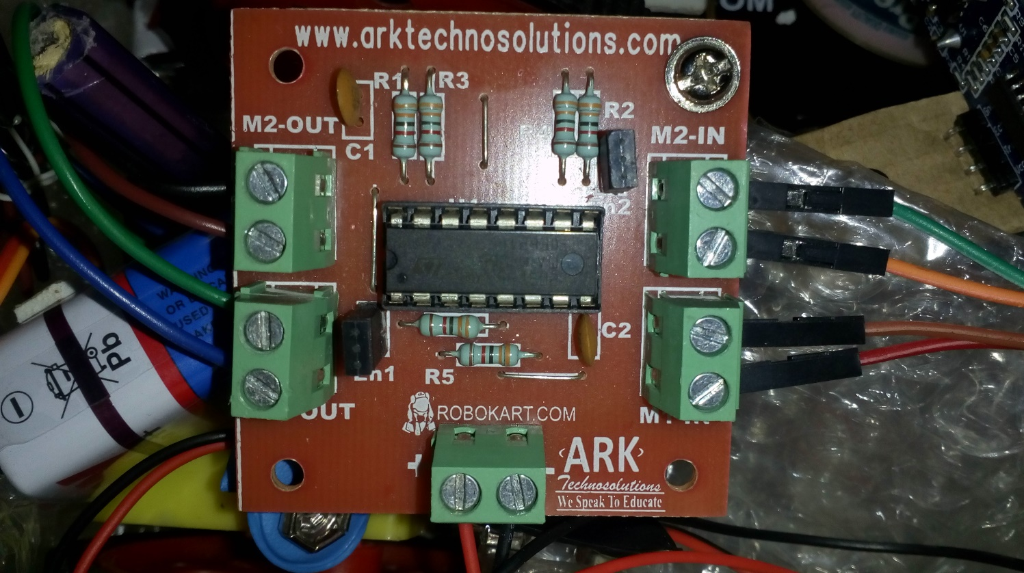
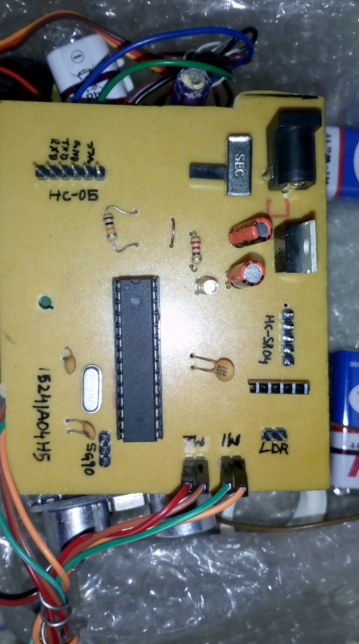

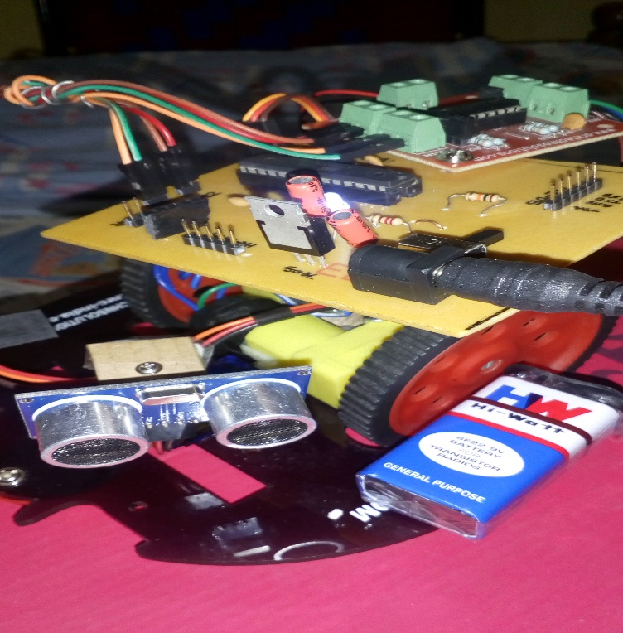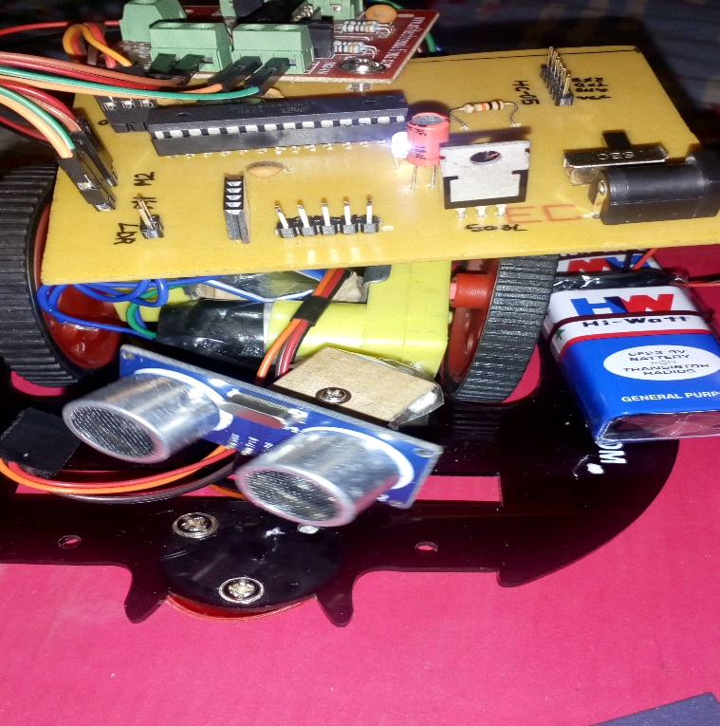

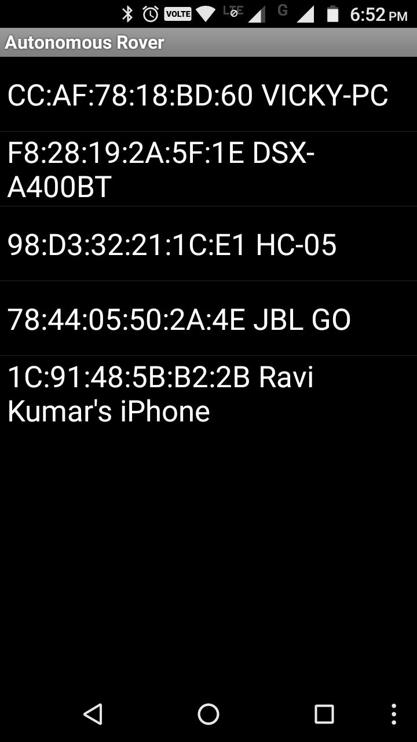
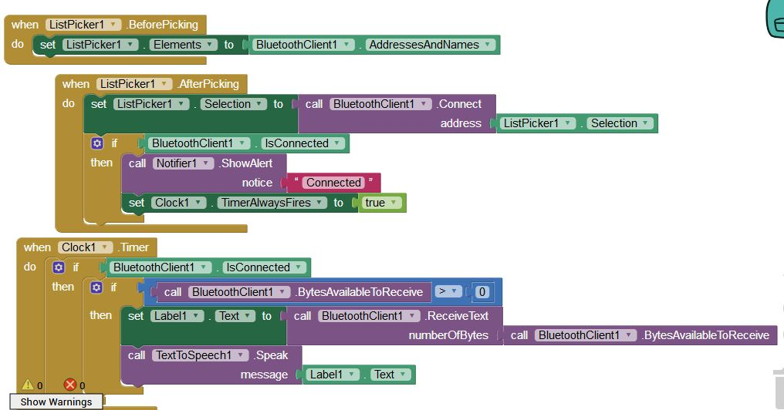

Applications
- Autonomous Rovers can be used in almost all mobile robot navigation systems.
- They can be used for space exploration and Planet’s Climatic and surface attributes.
- They can also be used in dangerous environments, where human penetration could be fatal.

Conclusion
The microcontroller based custom made PCB board is user friendly. The target surface needs to be perpendicular to the impinging ultrasound waves. The power level of the signal is too low for long range measurement. Less hardware are used so smaller in size. Inexpensive components used so that reduces the cost per unit. Major outcome is that this project can replaced too many costly types of equipment which we have to buy from foreign countries. Product is also eco-friendly because it does not harm Earth’s environment. Project is less complicated than other, so analysis and replacement of components is easy.

